RESEARCH AND DEVELOPMENT

Apache Superset - Visualization Tool

Apache Superset - Introduction

Superset is a modern open-source data exploration and data visualization platform that was originally developed at Airbnb. Superset can replace business intelligence tools for many teams. Superset integrates well with a variety of data sources.It allows users to create, manage, and explore data dashboards using an intuitive web-based interface.

Key Features and Aspects of Apache Superset:

- This tool makes it simple for users, even without deep technical skills, to define these custom categories and calculations.It's designed to be fast and flexible, allowing for quick adjustments as business needs change.

- Apache Superset is designed with strong security features, supporting integration with different authentication methods such as LDAP, OAuth, and database authentication to ensure safe access control.

- Being open-source, Superset offers flexibility for users to customize and expand its capabilities through plugins and custom code.This community-driven approach makes Superset accessible and adaptable, catering to a wide range of data analysis and visualization requirements.
Optimal Scenarios for Apache Superset Utilization
- Apache Superset offers extensive flexibility and control due to its open-source nature, allowing businesses to customize and adapt the tool to their specific needs.It supports a wide range of data sources including traditional SQL databases like MySQL and PostgreSQL, NoSQL databases such as MongoDB.

- Superset enables efficient exploration and visualization of data through interactive dashboards,charts, and reports. Additionally,enabling users to monitor and respond promptly.It allows updating dashboards dynamically as new data is received.

- Superset offers a wide range of visualization options including standard charts like bar and line graphs, making it easy to represent data in meaningful ways.

- Superset benefits from a collaborative community that ensures quick bug fixes, and ample support through shared knowledge and resources.

Scope of Apache Superset-

Apache Superset is particularly well-suited for various scenarios where robust data visualization, exploration, and collaboration are critical.

- Apache Superset is ideal for business intelligence and analytics, offering a user-friendly interface that allows business users and analysts to explore and visualize data from various sources.

- Superset promotes cross-functional collaboration by providing a platform for teams to share dashboards, annotations, and comments, ensuring that insights are accessible and understandable across the organization.

How to Use Apache Superset-

Using Apache Superset involves several key steps to get started and effectively utilize its capabilities for data visualization and business intelligence:

1. Installation and Setup: For installation, following are the requirements:

- Docker
- Docker Compose
- Git

Installation Method:

Clone the Repository: Open your terminal or command prompt and clone the Apache Superset repository from GitHub:

git clone https://github.com/apache/superset.git

Once that command completes successfully, you should see a new superset folder in your current directory.

Navigate to the Directory:

Change into the superset directory: cd superset

Launch Superset using Docker Compose commands:
- docker compose up
- docker compose -f docker-compose-image-tag.yml up (we just fetch and run pre-built images from docker-hub)

Log in to Superset:

Your local Superset instance also includes a Postgres server to store your data and is already pre-loaded with some example datasets that ship with Superset.
You can access Superset now via your web browser by visiting http://localhost:8088/login/
Log in with the default username and password:
username: admin
password: admin

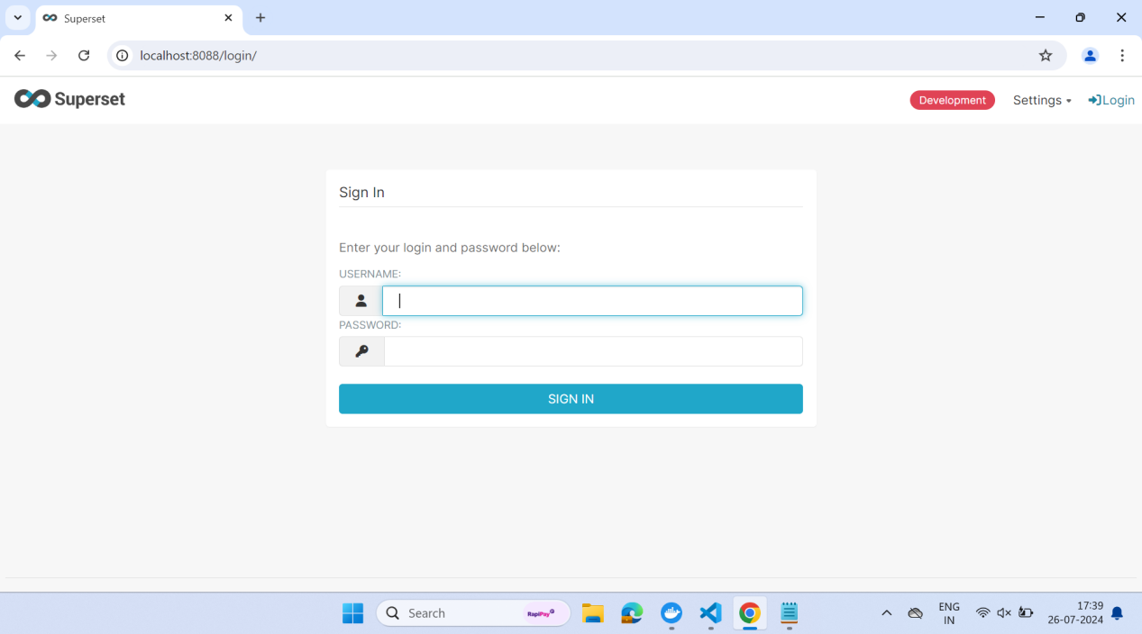
- Using docker compose -f docker-compose-image-tag.yml up command we are able to login to Superset as Apache Superset is connected to databases that are hosted on server ,but when using docker compose up we need to setup or configure databases locally so it is throwing errors of configurations that needs to be implemented in Apache Superset.

Dashboards

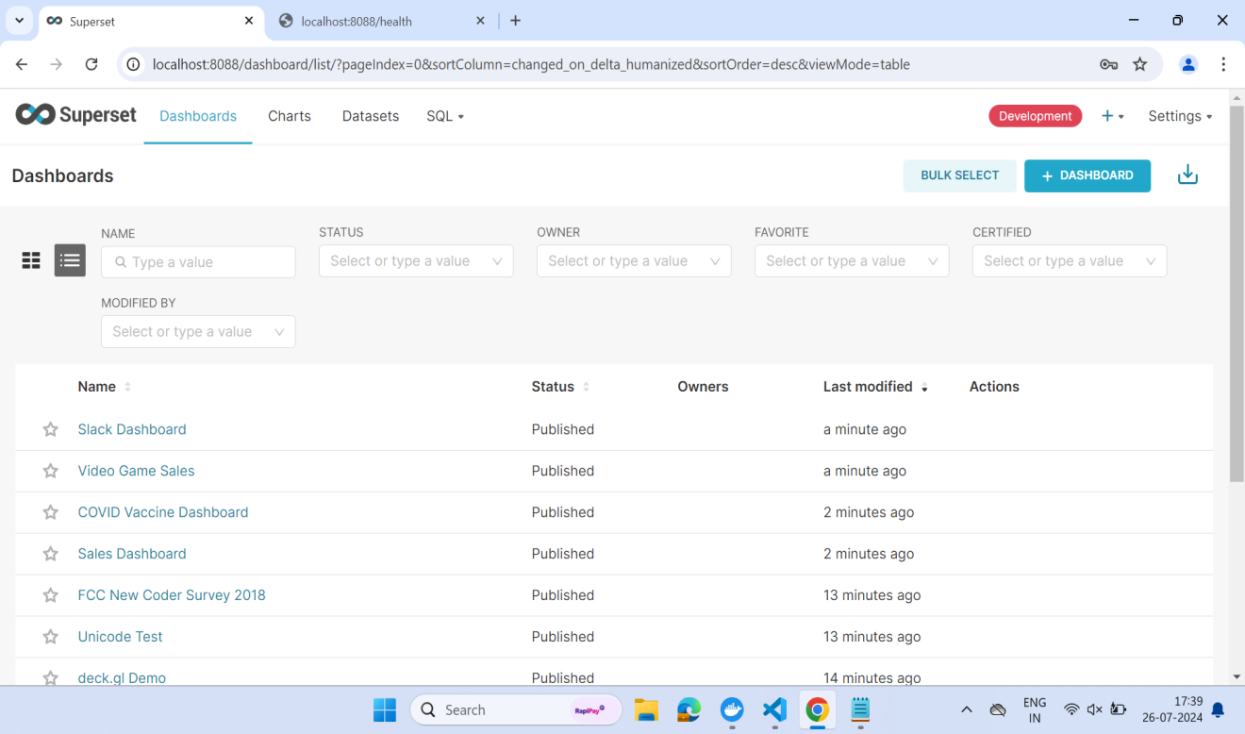

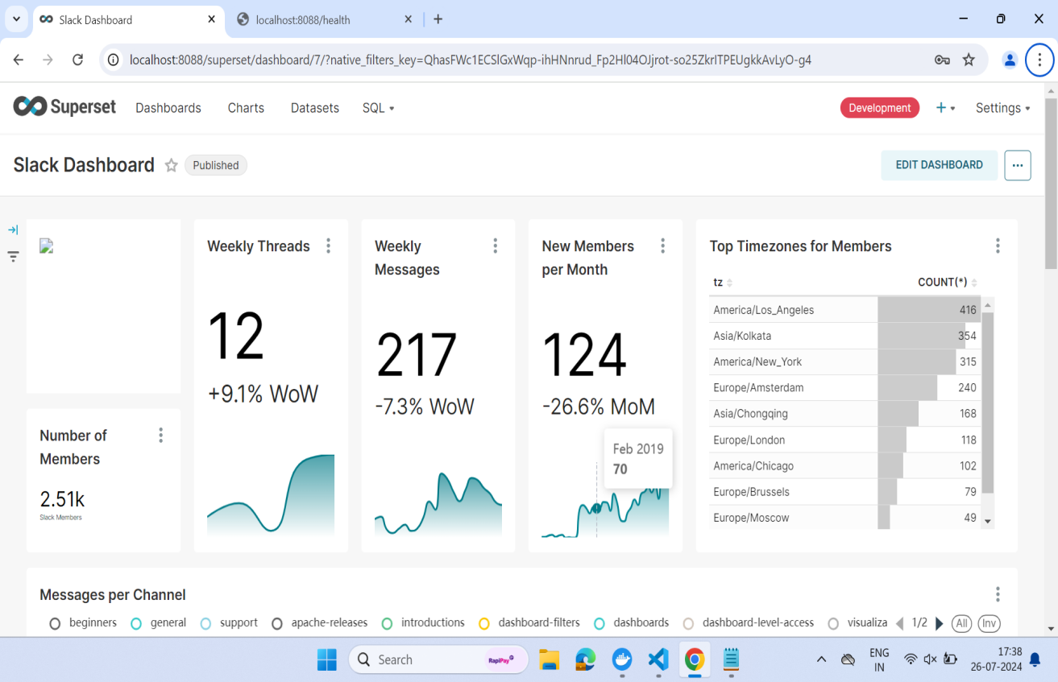

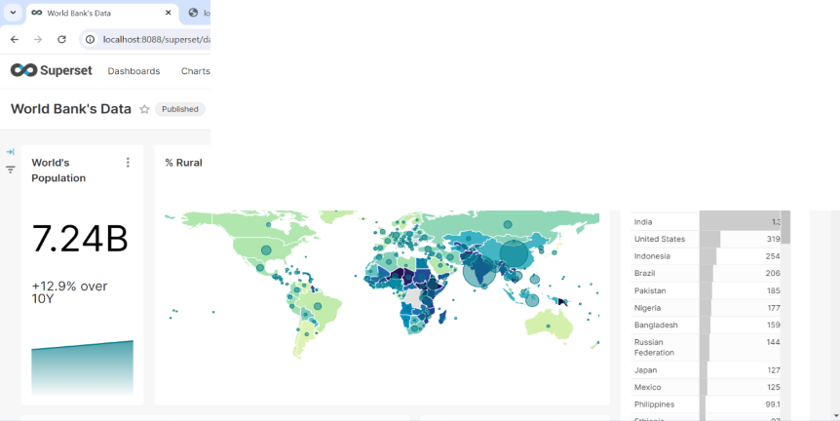

Supported Databases:
SQLite, MySQL, Athena, PostgreSQL, Oracle, Microsoft SQL Server, Druid, ClickHouse, Presto.

Supported File Formats:
CSV, Excel(XLS, XLSX), JSON, Parquet, ORC.

Pros & Cons of Apache Superset:

Pros:

- Superset offers a user-friendly interface that allows users to easily create and customize interactive dashboards, charts, and reports without extensive coding knowledge.

- Superset provides a wide range of visualization types (such as bar charts, line charts, scatter plots, maps, etc.) and customization options to effectively communicate data insights.

Cons:

- Setting up Superset can be complex, especially when configuring it to work with specific data sources or integrating with external authentication systems.

- While Superset is generally performant, the performance can vary based on the size of data being analyzed and the complexity of queries.

- Certain data sources may not be fully supported or may require additional configuration or development effort to integrate effectively with Superset.

AWS QuickSight VS Apache Superset:

AWS QuickSight and Apache Superset are both tools used for data visualization and analytics, but they differ in their approach and features:

- QuickSight is a managed business intelligence service provided by Amazon Web Services(AWS). Superset, is an open-source data exploration and visualization platform maintained by the Apache Software Foundation.

- Quicksight is designed to be integrated seamlessly with other AWS services,making it convenient for organizations already using AWS infrastructure. whereas Superset is suitable for organizations looking for flexibility,customization, and the ability to integrate with various data sources beyond AWS.

